Machine Problem 1

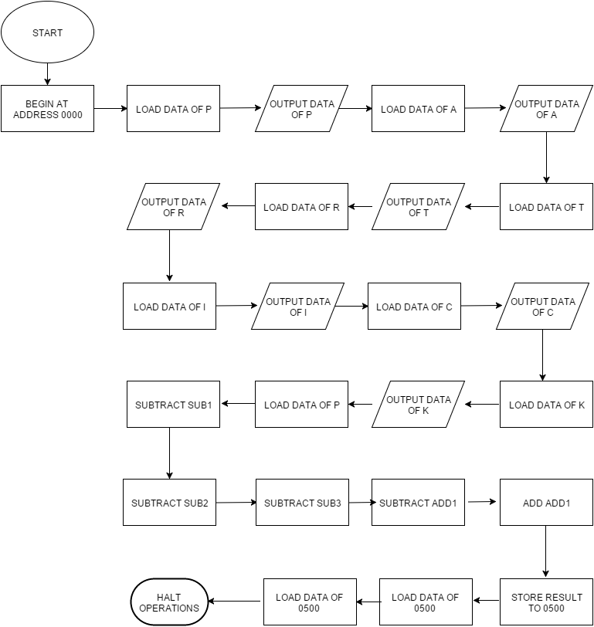

org 0000

load P

output

load A

output

load T

output

load R

output

load I

output

load C

output

load K

output

load P

subt sub1

subt sub2

subt sub3

add add1

store 0500

output 0500

output 0500

halt

P, dec 80

A, dec 65

T, dec 84

R, dec 82

I, dec 73

C, dec 67

K, dec 75

sub1, dec 7

sub2, dec 8

sub3, dec 30

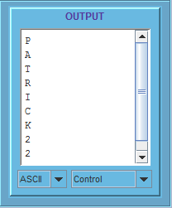add1, dec 1